

Engineering

Request for Proposal
Midway Marina – CPF WIFI Project

Christa Alexander
President

July 20, 2026

INTRODUCTION, OVERVIEW, AND APPROACH

Fulton Telephone Company, Inc. d/b/a Arriva an internet service provider, is seeking proposals to identify appropriate vendor to complete field work, engineering design, environmental assessment for fiber routes, site surveys for placement of the WIFI access points, inspection and project management for life of project including providing all documentation to satisfy CPF WIFI NOFO requirements for the project.

Summary of Project:

Engineer required to deploy field survey team utilizing field techniques achieving an absolute accuracy of +/- 0.1’and a ground based current street view image viewer with designs completed in CAD, create permits and manage the process of approvals with various permitting agencies, manage multiple quotes on materials and comparisons, project manage contractor selection process and entire construction project providing weekly updates and constant communication with both Arriva and the CPF WIFI funding agency. Engineer will be required to prepare a broad environmental assessment of the fiber project that follows the NTIA’s 7 CFR 1970 and NEPA standards. The project is in Itawamba County, MS and consists of utilizing existing underground fiber, adding handholes and splice cases where needed and drop placement and installation of eight (8) WIFI access points. Engineer must complete site survey at location for WIFI Access point placement. As part of the engineering service, it will be required that the engineer remain engaged for the entirety of the project providing all documentation to satisfy CPF WIFI NOFO requirements for the project and complete a final inspection upon turn up.

Proposals should be submitted to:
Christa Alexander
Email: calexander@goarriva.com

All proposals must be received by August 4, 2026

Question/Inquiry Process

All inquiries and questions related to this RFP must be directed IN WRITING via email to:

Christa Alexander
Email: calexander@goarriva.com

Proposal Requirements

- Contract will be awarded based on the highest scoring eligible candidate based on the scoring rubric included in the RFP.

- Where the Contractor is requested to supply information, include that information in the body of the proposal, or reference it is an attachment.

- A contractor may withdraw its proposal prior to the RFP response deadline. Proposals received after the deadline will not be considered. Proposals will be reviewed internally at the convenience of Arriva.

- Notwithstanding any other provision of this RFP, Arriva expressly reserves the right to:

    - Conduct discussions with any or all Vendors for the purpose of clarification of proposals.

    - Waive, or decline to waive, any insignificant defect or informality in any proposal or proposal procedures.

    - Accept, reject, or negotiate any or all proposals or the terms of any proposal, or any parts thereof, for the purpose of obtaining the best and final offer.

    - Cancel or amend this RFP or issue other requests for proposals.

    - Select a vendor(s) based on Arriva’s analysis and evaluation of proposals submitted. Arriva reserves the right to request presentations of proposals if Arriva feels further information is appropriate to the decision-making process.

    - Select no proposals at all.

    - Cancel an award if a vendor fails to negotiate in good faith and execute definitive written documents necessary to effectuate the transactions contemplated hereby in a manner consistent with the project’s timeline and within fifteen (15) days from the award date.

- A contractor and any subcontractor must be properly licensed and registered as required by the State of Mississippi necessary to complete the work contained in this RFP. Proper license and registration is required by each contractor before submitting a proposal. Each contractor may, before submitting a proposal, examine the site to determine the extent of work involved and the conditions under which the work would be performed. The contractor must have experience with compliance and reporting for CPF projects to ensure that the correct documentation is acquired. The submission of a proposal will be construed as evidence that such an examination has been made, and no subsequent allowance will be made in this regard on behalf of the vendor for any error or negligence on its part.

- Payments under the contract will be made by Arriva on no more than a monthly basis and final payment within 30 days after satisfactory completion and acceptance by Arriva.

Although notification will be provided to Vendors whose proposals are not accepted, further debriefing information will not be made available.

Description of Project

The Midway Marina project will provide free public access WIFI to the Midway Marina (Marina, parking and grounds with 8 strategically place Access Points) located at 641 Joe Wheeler Brown Rd, Fulton, MS 38843 in rural Itawamba County.

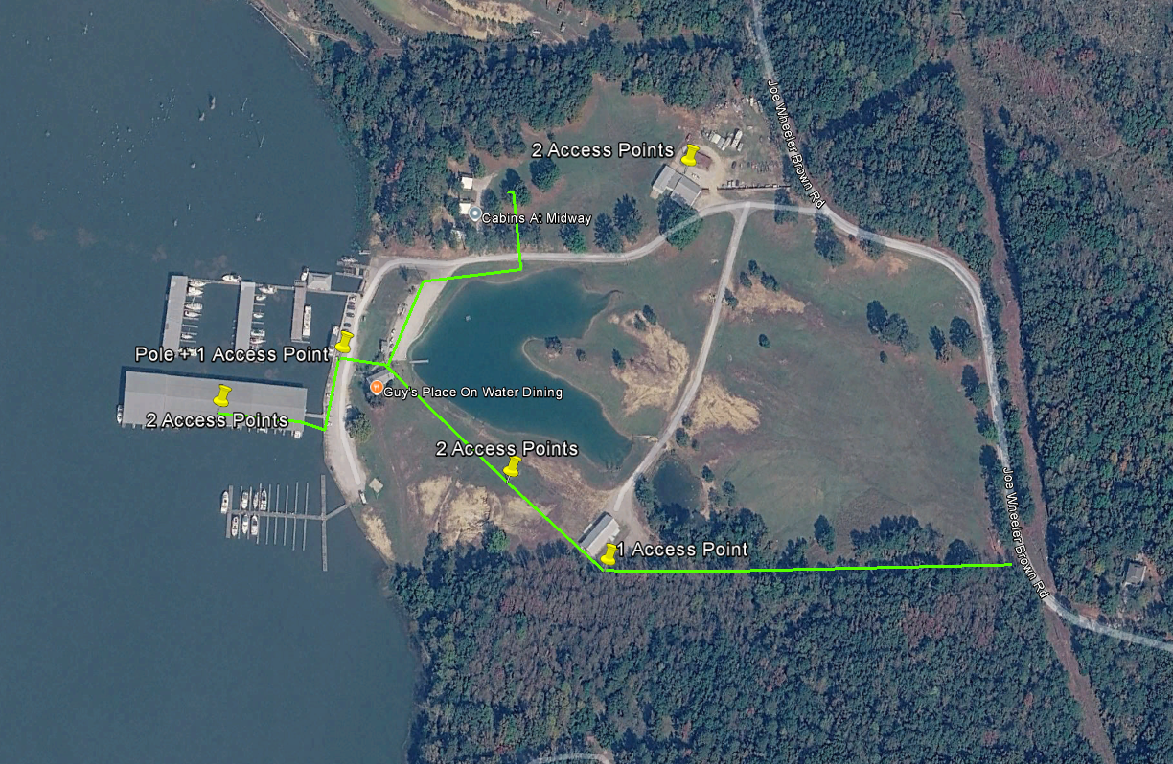

Description of Required Process:

Engineer will begin the process of reviewing each of the maps:

- Engineer with utilize base map fielding techniques that result in an absolute accuracy of +/- 0.1’, preferably mobile LiDAR.
- Engineer will design project for construction in AutoCAD.
- Engineer will complete all permits for owner submission to appropriate agency.
- Engineer will complete package for pole owner make-ready.
- Engineer will complete site surveys for WIFI access point placement.
- Engineer will solicit multiple material quotes and present comparison and lead times to owner.
- Engineer will assist owner in contractor bid process.
- Engineer will complete Environmental Checklist for CPF
  - Design will be provided to MDAH for review of Cultural or Historic Resources and any findings will be provided to Arriva to determine any changes to fiber design. SHPO information is submitted to https://www.mdah.ms.gov/historic-preservation/section-106-review.
  - ENGINEER will overlay the FEMA floodplain map and send the information to FEMA for review, if required.
  - ENGINEER will get an endangered species/migratory birds list from the department of the Interior and have the findings of no effect reviewed by Fisheries and Wildlife, if required.
  - ENGINEER will overlay the National Wetlands Inventory on top of the planned construction and submit a letter requesting permit review to the Army Corp of Engineers, if required.
  - Create a list of Tribes affected and submit letter requesting review, if additional information is needed engineer will send notice to Arriva for the tribal consultation, if required.
  - After reviewing all environmental impacts of this project, it will be combined into a single report to be submitted to funding agency for review and approval. Should funding agency need more information ENGINEER will lead the correspondence. ENGINEER will also provide an environmental impact statement to Arriva outlining all work requirements for the project and the best practice mitigation standards.
  - ENGINEER will review EPA Envirofacts Database, MS Oil and Gas Board Database, and Groundwater Assessment Database for any impact on above or below ground hazardous waste containment or disposal and provide mitigation practices if necessary.
  - Overlays for EPA Air Quality, Wild or Scenic Rivers, and Prime Farmland will be reviewed, and recommendations will be made if necessary.
  - Environmental Justice demographics will be reviewed for adverse impact on low-income or minority populations and if required will lead correspondence with the Council on Environmental Quality.
- Engineer will be expected to remain engaged throughout the project and provide support for Project Management and Compliance, including but not limited to procurement support, tracking project progress and reporting to funding agency, reimbursement process, attendance in funding agency updates and meetings, updating funding portal and other project compliance tasks as well as periodic inspection during and at the end of the project construction.

Please complete this page

Firm Name and Address: ___________________________________________

Officer Name: ____________________________________________________

Signature of Officer: ______________________________________________

Scoring Rubric (possible 100 points)

Engineering firm licensed in Mississippi and has local office in Mississippi 15 Yes / No
Engineering firm has environmental assessment experience 15 Yes / No
Engineering firm utilizes geospatial LiDAR based field survey equipment 15 Yes / No
Engineering firm has experienced in-house inspectors on staff for inspection 15 Yes / No
Engineering firm has experience with site surveys for WIFI access point placement 10 Yes / No
Engineering firm has experience with CPF WIFI projects in Mississippi 15 Yes / No
Engineering price for all requirements of RFP 15
Task Description | Price
Fieldwork and Design
Permitting
Environmental Assessment
Site Surveys for Access Point Placement
Material and Equipment Procurement
Contractor Selection Process
Network Testing
Inspections
As Builts
Total Engineering

